Southwest University
School of Computer & Information Science

Course Design Report

Course： Principles of Programming
Topic ： Cinema seat selection
Grade & class：Grade 2021 Class CS3
Student Name： Cai Qianzhe
Student No.： 222021321102065
Submission Date： 2021.12.09

Grade：2021
Comment:
The entire program and Course Design Report are completed by me independently.

Signature:蔡前哲

1、Description of the problem （main task and the problem you resolved）
Main task:
I need to design a program of seat selection for the movie theater. The program needs the following functions.
1) Display a seating layout diagram showing both sold and available seats.
2) User can select seats or retract seats with mouse.
3) User completes the virtual ticket purchase process and records the ticket information in a CSV file.

The problem I resolved:
Learning Tkinter and some related functions by myself first.
Design a program to simulate a real movie ticketing system. The program has the following functions.
Users can choose the movie they want to watch and select or retract seats. They can receive the movie information purchased by the them. Others can find the purchase information in a CSV file.
Use coordinates to determine whether the button and seat are clicked. This is the calculation draft and method.
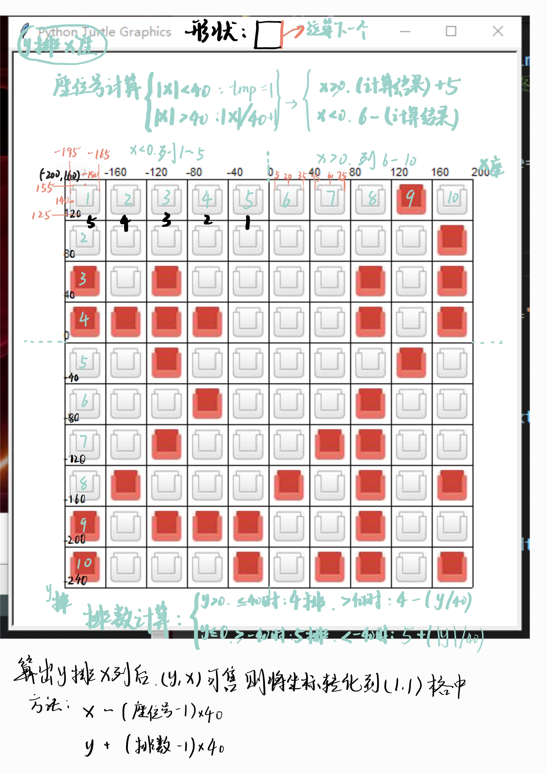
2、Basic Conceptions and Principles
1) The program has a beautiful GUI and a reasonable logic.
2) The program is as close to the real situation as possible.
3) Writing code as close to the standard as possible
4) The program structure is complete and can take into account the vast majority of user needs

3、Design Scheme（your plan, includes the structure of your program and the necessary description）
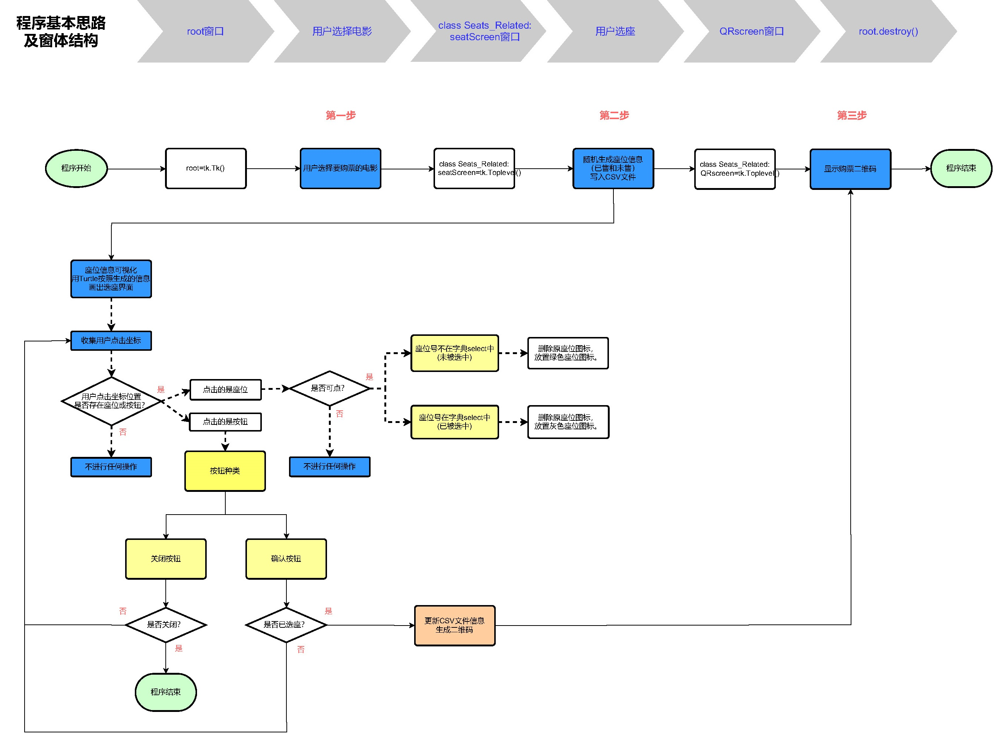
1) Design a program to simulate a real movie ticketing system.
2) Use Tkinter as GUI to let users choose the movie they want to watch.
3) Use Turtle on Tkinter canvas to realize select or retract seats.
4) Display and save a QR code of movie information purchased by the user.
5) Record tickets purchase information in a CSV file.

4、Resource Code（detailed comments are required）
import csv
import random
import tkinter as tk
import tkinter.messagebox
import turtle

import qrcode

# ---------------------选座页面--------------------------

class Seats_Related():
# 初始化类
def __init__(self, master, mv_num):
if mv_num == 1:
self.mv_Name = "扬名立万"
elif mv_num == 2:
self.mv_Name = "古董局中局"
elif mv_num == 3:
self.mv_Name = "长津湖"
elif mv_num == 4:
self.mv_Name = "门锁"
elif mv_num == 5:
self.mv_Name = "你的世界如果没有我"
elif mv_num == 6:
self.mv_Name = "只要你过的比我好"
elif mv_num == 7:
self.mv_Name = "梅艳芳"
elif mv_num == 8:
self.mv_Name = "笨鸟大冒险"
self.seatSold = [] # 记录座位是否已售出 0未售 1已售
self.select={} # 存储用户选择座位的字典
self.num = 0 # 已售座位数 即1的个数
# 创建选座窗口
self.seatScreen = tk.Toplevel(master=master)
self.seatScreen.title("电影《"+self.mv_Name+"》 请选择座位")
x, y = self.Cal_center(800, 800)
self.seatScreen.geometry("%dx%d+%d+%d" %(800,800,x,y))
self.seatScreen.resizable(width=False, height=False) #禁止拉伸

def Cal_center(self,w, h):
# 屏幕宽高
scnWidth = root.winfo_screenwidth()
scnHeight = root.winfo_screenheight()
# 窗口宽高
wdWidth = w
wdHeight = h
x = (scnWidth-wdWidth) / 2
y = (scnHeight-wdHeight) / 2
return x, y

def Seatmain(self):
self.canvas = tk.Canvas(master=self.seatScreen, width=800, height=800)

self.canvas.pack()
self.turtle_screen = turtle.TurtleScreen(self.canvas)
self.canvas_Seat = turtle.RawTurtle(self.turtle_screen)

self.Make_seats()
self.Draw_seats()

# 当点击窗口x退出时执行
self.seatScreen.protocol("WM_DELETE_WINDOW", on_closing) # 检测窗口关闭 捕获命令WM_DELETE_WINDOW
self.seatScreen.mainloop()

# ================功能与计算判断====================
""" 随机生成销售情况 空座 """
def Make_seats(self):
self.seatSold.clear() # 可能会多次调用该函数，先清除此前记录
file_seat = open("Seats.csv","w",encoding="utf-8-sig",newline="")
csv.writer(file_seat).writerow(["电影《"+self.mv_Name+"》"])
self.num = 0 # 已售座位数 即1的个数
row = [] # 记录每一排座位情况的临时list
# 生成已售和未售座位表
for i in range(10):
row.clear()
for j in range(10):
f = random.choice([0]*4+[1]*2) # 以未售约是已售概率的两倍随机生成
row.append(f)
if f == 1:
self.num += 1
self.seatSold.append(row.copy()) # 当前排生成完毕，加入list

# 写入csv文件
csv.writer(file_seat).writerow(["共100个座位，已售："+str(self.num)+" 未售："+str(100-self.num)])
for i in range(10):
csv.writer(file_seat).writerow(self.seatSold[i])
file_seat.close()

# ============================== 点击功能 =============================
""" 根据坐标计算座位号 """
def Cal_seatNumber(self,x,y):
zuo = 0
if abs(x) < 40 :
tmp = 1
else:
tmp = int(abs(x)/40)+1
if(x >= 0):
zuo = 5+tmp
else:
zuo = 6-tmp

pai = 0
tmp = int(abs(y)/40)
if y > 0:
if y <= 40:
pai = 4
else:
pai = 4-tmp
else:
if y >= -40:
pai = 5
else:
pai = 5+tmp

return pai, zuo

""" 判断是否可以选中 """
def Check_ClickIcon(self,pai, zuo, x, y):
if zuo != 1:
x -= (zuo-1)*40
if pai != 1:
y += (pai-1)*40

if -195<=x<=-165 and 125<=y<=155:
if self.seatSold[pai-1][zuo-1] == 1: # 此前已被售出，不可选
return 0
if (pai,zuo) not in self.select: # 可以选择
self.select[(pai,zuo)] = 1
return 1
if self.select[(pai,zuo)] == 1: # 已被选，点击应取消选择
del self.select[(pai,zuo)]
return 2

""" 计算x排x座对应的画笔坐标，用于选择座位时替换原图标 """
def Cal_pos(self,pai,zuo):
x = -180+40*(zuo-1)
y = 140-40*(pai-1)
return x,y

""" 点击确定按钮 """
def Button_Yes(self):

if not self.select: # 用户没选择座位
if tkinter.messagebox.showwarning(title="提示", message="您还没有选择座位，请选择合适的座位进行购票。"):
pass
else:
file_seat = open("Seats.csv", "a+", newline='', encoding="utf-8-sig") # 写入用户购买信息
csv.writer(file_seat).writerow(["用户未买票"])
file_seat.close()
root.destroy()
else: # 用户已选座位
# 用户购买信息已确定，更新列表并新建字符串便于输出
str_selectSeats = "" # 把用户选择的座位转成字符串，便与输出
for pai,zuo in self.select.keys():
str_selectSeats += (str(pai)+"排"+str(zuo)+"座 ")

if tkinter.messagebox.askyesno(title="提示", message="电影《"+self.mv_Name+"》\n您选择的座位是："+str_selectSeats+".\n是否需要重选？", default="no"):
pass
else:
for pai,zuo in self.select.keys():
self.seatSold[pai-1][zuo-1] = 1 # 更新列表 用户新选的座位变为已售
self.num += len(self.select)
file_seat = open("Seats.csv", "w", newline='', encoding="utf-8-sig") # 需要重新覆盖写入，更新用户购买信息
csv.writer(file_seat).writerow(["电影《"+self.mv_Name+"》"])
csv.writer(file_seat).writerow(["共100个座位，已售："+str(self.num)+" 未售："+str(100-self.num)])
for i in range(10):
csv.writer(file_seat).writerow(self.seatSold[i])
csv.writer(file_seat).writerow(["用户购买了"+str_selectSeats])
file_seat.close()
self.seatScreen.destroy()

# ==================== 二维码功能==================
# 创建窗口
self.QRscreen = tk.Toplevel(master=root)
self.QRscreen.title("购票成功")
# 生成二维码
qr = qrcode.QRCode()
qr.add_data("您购买的电影为《"+self.mv_Name+"》\n座位："+str_selectSeats)
img_QR = qr.make_image(fill_color='black', back_color='white') # 生成二维码
img_QR.save("Ticket.png") # 保存到硬盘上
# 窗口显示
lwords = tk.Label(self.QRscreen,text="请保留好观影二维码(已自动保存至程序文件夹)，欢迎再次光临！")
lwords.pack()
img_QR = tk.PhotoImage(master=self.QRscreen, file="./Ticket.png")
tk.Label(self.QRscreen,image=img_QR).pack()
tk.Button(self.QRscreen,width=20,height=2,text="确定", command=root.destroy).pack()
#取得并计算窗口大小参数 自动居中窗口
self.QRscreen.update() # 更新窗口数据 否则获取的窗口宽高永远为1
wdWidth = self.QRscreen.winfo_width()
wdHeight = self.QRscreen.winfo_height()
x, y = self.Cal_center(wdWidth, wdHeight) # 设置宽高 窗口自动居中
self.QRscreen.geometry("%dx%d+%d+%d" %(wdWidth,wdHeight,x,y))

# 当点击窗口右上x退出
self.QRscreen.protocol("WM_DELETE_WINDOW", root.destroy) # 检测窗口关闭 捕获命令WM_DELETE_WINDOW

self.QRscreen.mainloop()

""" 点击按钮区域+选座功能 """
def Click_deal(self, x, y):
# 处理点击确定按钮
if -40<=x<=40 and -330<=y<=-290: # 点击了确定按钮
self.Button_Yes()

# 处理点击座位
pai, zuo = self.Cal_seatNumber(x,y) # 计算座位号

if 1<=pai<=10 and 1<=zuo<=10: # 该座位号存在
f = self.Check_ClickIcon(pai, zuo, x, y) # 检查是否可以选中 0不可选 1变绿 2变灰
if f == 1: # 选中变绿
self.canvas_Seat.goto(self.Cal_pos(pai,zuo))
self.canvas_Seat.clearstamp(self.idSeat[pai-1][zuo-1])
self.canvas_Seat.shape(shapeGreen)
self.idSeat[pai-1][zuo-1] = self.canvas_Seat.stamp()
elif f == 2: # 取消选择 变灰
self.canvas_Seat.goto(self.Cal_pos(pai,zuo))
self.canvas_Seat.clearstamp(self.idSeat[pai-1][zuo-1])
self.canvas_Seat.shape(shapePray)
self.idSeat[pai-1][zuo-1] = self.canvas_Seat.stamp()

# ================绘图-===================

""" 无痕移动到某一坐标 用于画辅助元素 """
def Goto(self, x, y):
self.canvas_Seat.penup()
self.canvas_Seat.goto(x,y)
self.canvas_Seat.pendown()

""" 画矩形 """
def Draw_rectangle(self, length, width):
self.canvas_Seat.forward(length)
self.canvas_Seat.right(90)
self.canvas_Seat.forward(width)
self.canvas_Seat.right(90)
self.canvas_Seat.forward(length)
self.canvas_Seat.right(90)
self.canvas_Seat.forward(width)

idSeat = [] # 二维数组 记录每个座位的stamp_id，便于点击时清除
def Draw_seats(self):
self.canvas_Seat.speed(0)
self.turtle_screen.delay(0)
self.turtle_screen.bgcolor("lightyellow")

self.turtle_screen.addshape(shapePray)
self.turtle_screen.addshape(shapeGreen)
self.turtle_screen.addshape(shapeRed)
# AuxiliaryLine() #画辅助网格

# ===========================根据销售情况生成最初座位==========================
self.canvas_Seat.penup()
self.canvas_Seat.setheading(0)
x = -180
y = 140

row = [] # 记录每一排stamp_id的临时数组
for i in range(10): # 画行
row.clear()
for j in range(10): # 画列
self.canvas_Seat.goto(x,y)
if self.seatSold[i][j] == 1: # 根据Make_seat函数生成的座位来决定放置座位颜色
self.canvas_Seat.shape(shapeRed)
else:
self.canvas_Seat.shape(shapePray)
row.append(self.canvas_Seat.stamp()) #放置座位并记录id
x += 40
self.idSeat.append(row.copy())
x = -180
y -= 40

# ===================画辅助元素=================
# 排号旁的竖线
self.canvas_Seat.color("pink") #sandybrown
self.canvas_Seat.pensize(1)
self.Goto(-210,170)
self.canvas_Seat.setheading(270)
self.canvas_Seat.forward(420)
self.canvas_Seat.penup()

# 排号文字
self.canvas_Seat.color("black")
y = 130
for i in range(1,10):
self.Goto(-230,y)
self.canvas_Seat.write(str(i),move = False, font=("黑体", 18, "normal"))
y -= 40
self.Goto(-237,y)
self.canvas_Seat.write("10", move = False, font=("黑体", 18, "normal"))

# 屏幕中央线+长方形
self.canvas_Seat.color("lightgreen")
self.Goto(0,200)
self.canvas_Seat.pensize(2)
self.canvas_Seat.setheading(270)
self.canvas_Seat.forward(450) # 屏幕中央线
self.Goto(-55,205)
self.canvas_Seat.color("lightgreen")
self.canvas_Seat.pensize(10)
self.canvas_Seat.setheading(0)
self.canvas_Seat.begin_fill()
self.Draw_rectangle(110,35) # 矩形
self.canvas_Seat.end_fill()
self.Goto(-48,175)
self.canvas_Seat.color("white")
self.canvas_Seat.write("银幕中央", move = False, font=("楷体", 18, "bold"))

# 最上方三个座位图标说明
self.Goto(-1200,365) # 画底色
self.canvas_Seat.color("linen")
self.canvas_Seat.pensize(50)
self.canvas_Seat.setheading(0)
self.canvas_Seat.forward(2400)
self.canvas_Seat.penup()
self.Goto(-180,365) # 说明图标
self.canvas_Seat.shape(shapePray)
self.canvas_Seat.stamp()
self.canvas_Seat.forward(150)
self.canvas_Seat.shape(shapeGreen)
self.canvas_Seat.stamp()
self.canvas_Seat.forward(150)
self.canvas_Seat.shape(shapeRed)
self.canvas_Seat.stamp()
self.Goto(-155,353) # 说明文字
self.canvas_Seat.penup()
self.canvas_Seat.color("black")
self.canvas_Seat.write("可选", move = False, font=("黑体", 19, "normal"))
self.canvas_Seat.forward(150)
self.canvas_Seat.write("已选", move = False, font=("黑体", 19, "normal"))
self.canvas_Seat.forward(150)
self.canvas_Seat.write("已售", move = False, font=("黑体", 19, "normal"))

# 画银幕梯形
self.Goto(-200,340)
self.canvas_Seat.setheading(320)
self.canvas_Seat.pendown()
self.canvas_Seat.pensize(3)
self.canvas_Seat.pencolor("lightcyan")
self.canvas_Seat.fillcolor("lightcyan")
self.canvas_Seat.begin_fill()
self.canvas_Seat.forward(60)
self.canvas_Seat.left(40)
self.canvas_Seat.forward(300)
self.canvas_Seat.left(40)
self.canvas_Seat.forward(60)
self.canvas_Seat.end_fill()

# 银幕文字
self.Goto(-95,300)
self.canvas_Seat.color("cornflowerblue")
self.canvas_Seat.write("影 厅 银 幕", move = False, font=("黑体", 25, "bold"))

# 确定按钮
self.Goto(-40,-290)
self.canvas_Seat.color("palegreen")
self.canvas_Seat.setheading(0)
self.canvas_Seat.begin_fill()
self.Draw_rectangle(80,40)
self.canvas_Seat.end_fill()
self.Goto(-26,-325)
self.canvas_Seat.color("black")
self.canvas_Seat.write("确定", move = False, font=("宋体",20,"normal"))

self.canvas_Seat.penup()
self.canvas_Seat.hideturtle()
self.turtle_screen.onscreenclick(self.Click_deal)
# ====================选座页面主程序=============================
""" 选座程序 """
def Seats(mv_num):
root.withdraw()
s = Seats_Related(root, mv_num)
s.Seatmain()
# --------------------------end------------------------

# ------------------首页-----------------
""" 注册并添加图标 全局变量 其它函数可用 """
shapePray = "./img/pray.gif"
shapeRed = "./img/red.gif"
shapeGreen = "./img/green.gif"

""" 显示图片 """
def Show_Image():
for i in range(1,5):
l = tk.Label(frm_Up, image=img_mv[i])
l.grid(row=0, column=i-1) # 图片list下标从1开始，grid列从0开始，差一个

for i in range(5,9):
l = tk.Label(frm_Down, image=img_mv[i])
l.grid(row=0, column=i-5)

""" 设置按钮 """
def Show_Buttom():
# 点击按钮传入电影编号便与输出 启动选座界面
tk.Button(frm_Up, text="点击购票", activebackground="white", cursor="hand2", command=lambda: Seats(1)).grid(row=1, column=0)
tk.Button(frm_Up, text="点击购票", activebackground="white", cursor="hand2", command=lambda: Seats(2)).grid(row=1, column=1)
tk.Button(frm_Up, text="点击购票", activebackground="white", cursor="hand2", command=lambda: Seats(3)).grid(row=1, column=2)
tk.Button(frm_Up, text="点击购票", activebackground="white", cursor="hand2", command=lambda: Seats(4)).grid(row=1, column=3)
tk.Button(frm_Down, text="点击购票", activebackground="white", cursor="hand2", command=lambda: Seats(5)).grid(row=1, column=0)
tk.Button(frm_Down, text="点击购票", activebackground="white", cursor="hand2", command=lambda: Seats(6)).grid(row=1, column=1)
tk.Button(frm_Down, text="点击购票", activebackground="white", cursor="hand2", command=lambda: Seats(7)).grid(row=1, column=2)
tk.Button(frm_Down, text="点击购票", activebackground="white", cursor="hand2", command=lambda: Seats(8)).grid(row=1, column=3)

""" 首页显示 """
def Show_main():
label_title = tk.Label(root, width=20, height=2, text="正在热映(8部)", fg="red",font=("黑体",20))
label_title.pack()

Show_Image()
Show_Buttom()

frm_Up.pack()
frm_Down.pack()
# -------------------end-----------------------

""" 获得屏幕分辨率，计算窗口参数 用于自动居中窗口 """

def Cal_center():
# 屏幕宽高
scnWidth = root.winfo_screenwidth()
scnHeight = root.winfo_screenheight()
# 窗口宽高
wdWidth = 1000
wdHeight = 650
x = (scnWidth-wdWidth) / 2
y = (scnHeight-wdHeight) / 2
root.geometry("%dx%d+%d+%d" %(wdWidth,wdHeight,x,y))

# ------------------主程序----------------

root = tk.Tk()
Cal_center() # 设置窗口宽高并居中
root.title("电影购票系统")
root.resizable(width=False, height=False) # 禁止拉伸

# 首页的两个框架 上下显示
frm_Up = tk.Frame(root)
frm_Down = tk.Frame(root)

# 导入图片 全局变量
img_mv = []
img_mv.append(0) # 使下面的图像与下标对应
for i in range(1,9):
img_mv.append( tk.PhotoImage(master=root, file="./img/mv"+str(i)+".png"))

Show_main()

# 当点击窗口右上x退出时执行
def on_closing():
if tkinter.messagebox.askokcancel("询问", "是否退出购票", default="cancel"):
root.destroy()
root.protocol("WM_DELETE_WINDOW", on_closing) # 检测窗口关闭 捕获命令WM_DELETE_WINDOW

root.mainloop()

5、Instructions(give the steps and necessary screenshot to show how to run your program):
First of all, the computer should install the qrcode library and PIL library
(These can be installed with pip command: “pip install qrcode” “pip install pillow”)
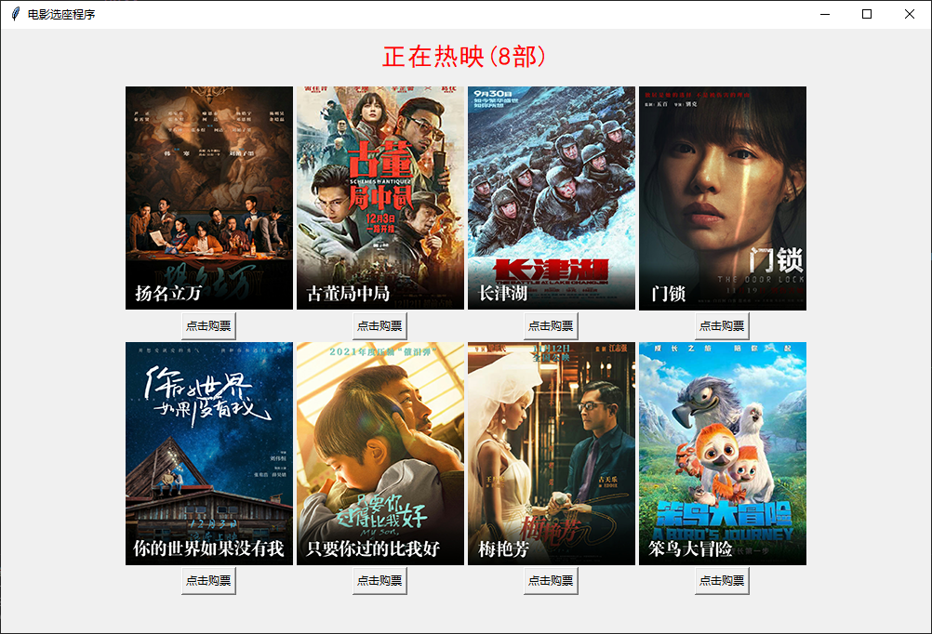
Secondly, compile and run the file called main.py. Seeing this interface means you are successful.
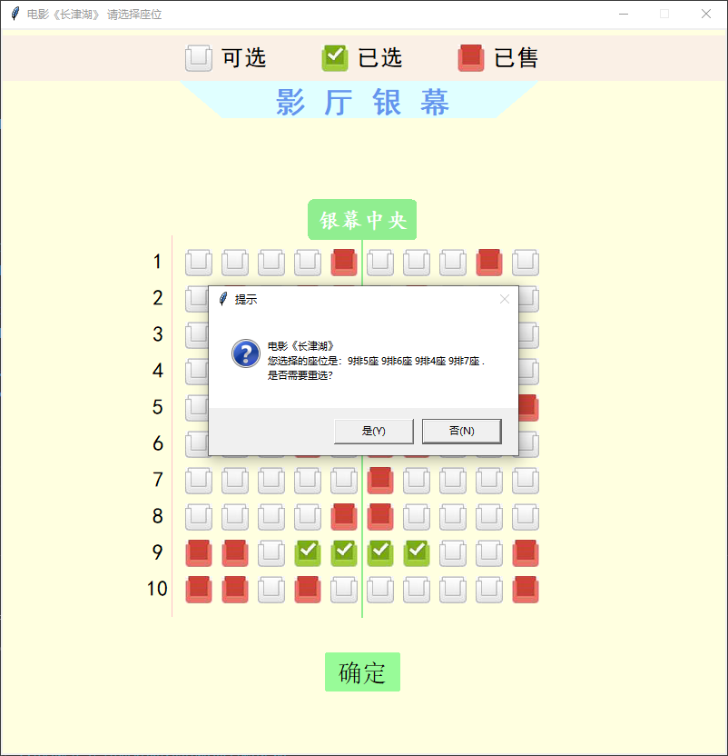
Then you can choose a movie you like from these films and you will enter the seats selection interface, just like below.
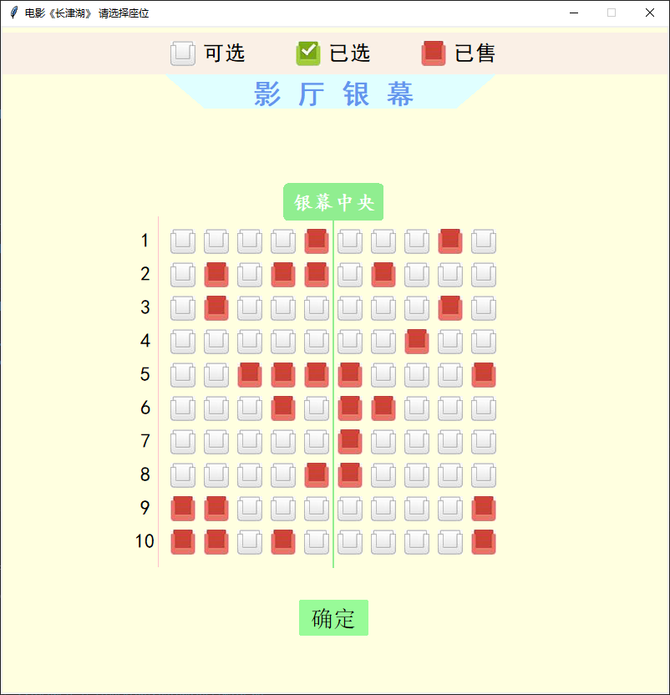
After selecting the seats, you will receive a QRcode. It’s your purchase information.
(The picture on the right is the result of scanning the QRcode)
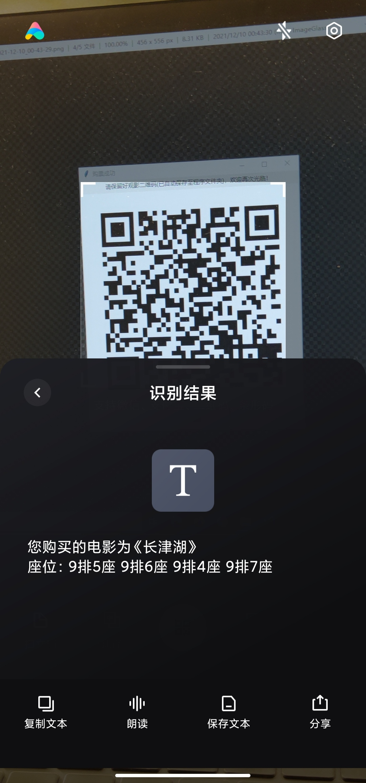
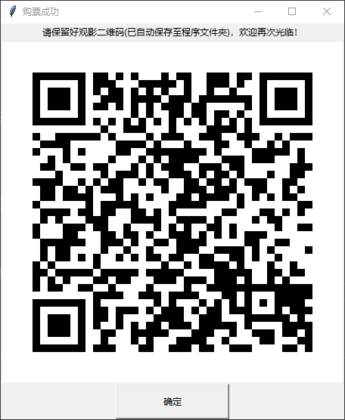
Besides, manager can check the sales status in the CSV file.
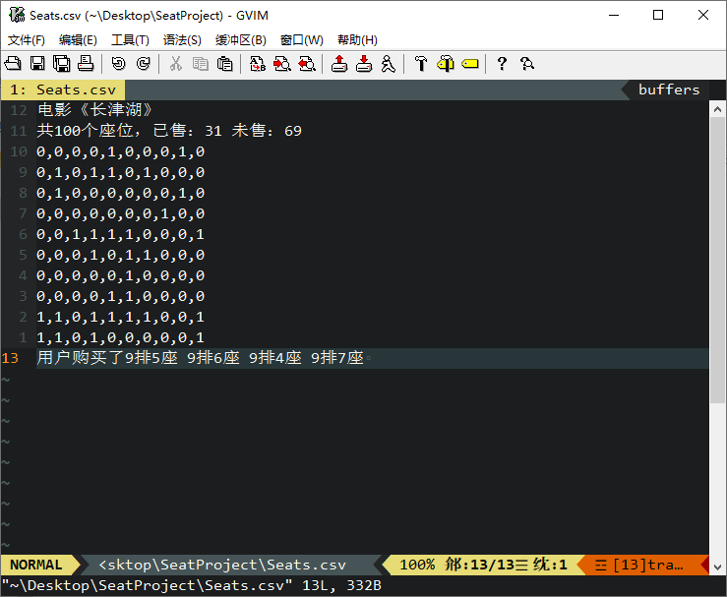

It’s all the files in the folder. (The latter two files are automatically generated after the program runs.)
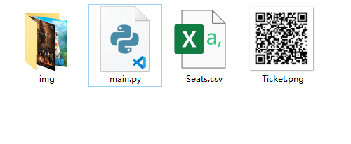
6、Summary
1) Use object-oriented programming when creating the window. Creating the window in the class. Otherwise it will be difficult to transfer information between windows.
2) Good at looking up information, many problems will be solved easily.
3) Learn new content in practice to understand faster and better. Especially when learning new functions.
4) Code comments and specifications are important. When the code is very long, it is difficult to debug in non-standard code.

